|  |  |
| --- | --- |
| Forum: | United Nations Environment Programme |
| Issue: | On measures to mitigate the negative impacts of air pollution in MEDC’s and LEDC’s |
| Student Officer: | Helen Wong |

**Overview**

In the modern world, countries have been trying to adress the issue of negative impacts of air pollution in both MEDC’s and LEDC’s, this issue is reflected the United Nations Sustainable Development Goals. Goal 3, 7, 12, 13, and 17 all adress this topic. Throughout the world, 41% of the households (over 2.8 billion people) rely on solid fuels (coal and biomass) for cooking and heating, especially in developing countries in Asia and Sub-Saharan Africa where these fuels are predominantly used.

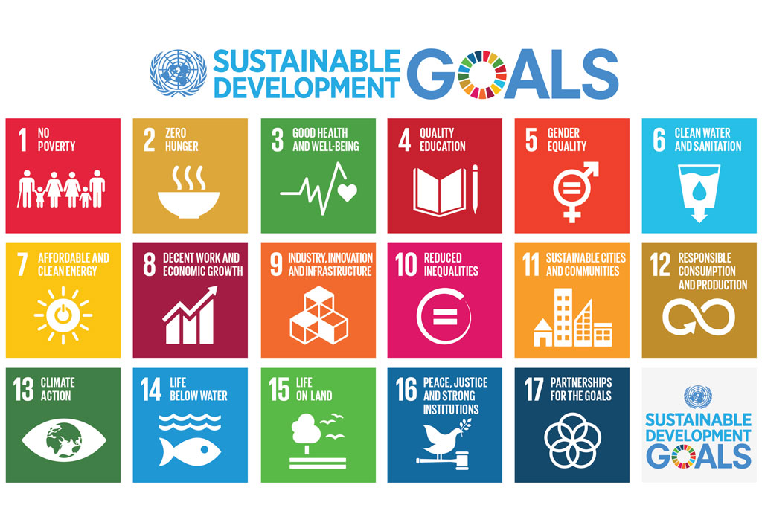

The effects of air polution is mainly from greenhouse gases, fossil fuels released by vehicles and factories, and methane which is released by livestock. Air pollution can increase the chance of climate change by raising the earth’s temperature, climate change can cause this issue to be worse, through creating more allergenic air pollutants, such as mold caused by damp conditions and longer pollen season, from increased pollen production.

Air pollution can have a serious health impact on humans, science has proven, individuals who are exposed to a very high level of air pollutants have experienced irritation to the eyes, nose and throat, wheezing, coughing and breathing problem and have a greater risk of heart attack. Air pollution can also exacerbate existing lungs and heart conditions and trigger asthma attacks.

The goal of this committee is for countries to come up with solutions to mitigate the issue of air pollutions in countries

**Key Terms**

**Air pollution**

Pollution of the atmosphere, contamination of air caused by harmful substance such as oxides of carbon, sulfur, nirtogen and other harmful gases.

**Greenhouse gas**

Gas that absorbs and emits radiant energy within the thermal infrared and stops heat from escaping from the atmosphere, such as carbon dioxide.

**LEDC**

Less economically developed country, also known as a developing country, LEDC’s are usualy relatively poor

**MEDC**

More economically developed country, MEDC’s are usually countries that are more advanced, industrialized or more developed.

**Exacerbate**

Make something worse

**Black carbon**

“short lived climate pollutant” (SLCP), a major components of health harmful PM 2.5 air pollution-particularly from diesel vehicles, diesel engines, coal/biomass stoves and waste incineration.

**Ground level Ozone**

This is also an SLCP, but is formed by a mix of air pollutants emitted over cities or nearby rural areas, including methane (another SLCP) from urban sewage and agriculture.

**Background Information**

The Clean air act authorizes the U.S. EPA to protect public health by regulating the emissions of these harmful air pollutats. The NRDC has been a leading authority of this law since it was established in 1970.

Air pollution comes from many sources, such as, cookstoves, kerosene lamps to coal fried power plants, vehicle emissions, industrial furnaces, wildfires and sand and dust storms, this issue mainly focuses particulary in Africa and Asia, especially in low and middle income countries, 98% of the cities with more than 100,000 inhabitants fail to meet the WHO’s air quality guidelines. The UNEP are working, by supporting cleaner fuels and vehicles, inspring individuals and city leaders to act, strengthening laws and institutions and developing affordable technologies to monitor air quality.

**Important Events/Timelines**

|  |  |  |  |
| --- | --- | --- | --- |
| **Date**   |  |  | | --- | --- | | **1955** | The United Nation Environmental Programs (UNEP) was established at that time for solving environmental problems with world cooperations. |   **1963**  **1967** UNEA asked UNEP to support global efforts to improve air quality. UNEP has launched several programmes, such as develop a low cost sensor that can be used across the developing worl to track pollution hotspots | **Event**  The Air Pollution Control Act was the first Clean Air Act established in the United States. This was “an act to provide research and technical assistance relating to air pollution control”  Clean Air Act- A new law that provided funds for research on the soures and effects of air pollution, first federal legislation to acknowledge that air pollution was not a local problem, but a problem that crossed the boundaries of local and state jurisdictions. Through this act, the federal government began to publish national air quality standards, although these were only recommendations. The federal government had very little enforcements power, and air quality issues remained primarily a local concern.  Clean Air Act Amendments- This legislation converted the air quality criteria requested in 1963 into requirements and listed specific regions known for air pollution problems as special air quality control regions |
| **1970**  **1970**  **1972**  **2012** | National Environmental Policy Act (NEPA)- This law stated plainly that it was the duty of the U.S. government to “encourage productive and enjoyable harmony between man and his environment” and encouraged the President to create two environmental agencies: (1)The Council on Environmental Quality, based out of the White House, to advise the President, and (2) the Environmental Protect Agency (EPA), to assume responsibility for environmental regulation and protection.  Clean Air Act Amendments- The 1970 Clean Air Act launched an ambitious national campaign to reduce air pollution. This 1970 legislation is still the basis of our national air pollution prevention program. It expanded air quality control to all areas. It also funded more extensive air quality and pollution research than been been before. Another result of this law was the establishment of required (not just recommended, as in 1963) National Ambient Air Quality Standards(NAAQS) for six criteria pollutions. To ensure compliance with these standards, the law initiated regulation of both stationary and modile sources of air pollutants. States were required to develop plans as to how they would meet clean air standards in polluted areas. Optimistic compliance deadlines in the law, however, were often not achieved, and many regulations were waived and enforcement actions delayes. This law also permitted citizens to bring lawsuits against voilators of the NAAQS  The United Nation Environmental Programs (UNEP) was established at that time for solving environmental problems with world cooperations.  In Beijing, China, alone had reported a regional economic loss of about 17 billion yuan due to natural disasters caused by environmental pollution in China, due to rising urgency, an inductry has developed around environmental protection, generating total revenue of more than three trillion yuan in 2011. |

**2014** UNEA asked UNEP to support global efforts to improve air quality. UNEP has launched several programmes, such as develop a low cost sensor that can be used across the developing worl to track pollution hotspots.

**Major Nations/Organizations**

**United Nations Environmental Program (UNEP)**

The UNEP is an agency of United Nations (UN) and coordinates its environmental activities, assissting developing countries in implementin environmentally sound policies and practices.

**World Health Organization (WHO)**

The WHO is a specialized agency of the United Nations (UN) that is concerned with international public health

**Environmental Protection Agency** (**EPA)**

The EPA is an independent agency of the United States federal government for environment protection.

**Climate and Clean Air Coalition (CCAC)**

The climate and Clean Air Coalition to Reduce Short-Lives Climate Pollutants was lunched by the United Nations Environment Programme and six countries: Bangladesh, Canada, Ghana, Mexico, Sweden and United States

**Air Pollution Control Act (APCA)**

The Air Pollution Control Act of 1955 was the first Clean Air Act encted by Congress to address the national environment problem of air pollution on July 14, 1955.

**Important Documents/Passed Solutions**

The Paris Agreement is an agreement within the United Nations Framework Convention on Climate Change (UNFCCC), which deals with greenhouse-gas-emissions mitigation, adaptation, and finance, starting in the year 2020. This was negotiated by representatives of 196 state consensus on 12 december 2015.

The Clean Air Act launched an ambitious national campaign to reduce air pollution during 1970

**Possible Solutions**

Air pollution has always been a major issue that effects the environment and human health, and different major nations and organizations has taken part to mitigate the negative impact of air pollution.

To start with, countries should write new laws, legislation and regulations to mitigate the issue of air pollution. This can relieve many cities and countries that are heavily polluted and have substainially attained clean are mainly due to the institutionalization of anti-pollution laws.

Fossil fuel and coal are the main contributors to air pollution, therefore, countries should offer and encourage citizens and other members of the country to use renewable or green energy sources.

Although fossil fuel and coal are the main causes of air pollution, power plants, factories and vehicles also are the leading sources of air pollution, they constantly emit fumes and gaseous waste into the atmosphere. To mitigate this issue, countries should promote and develop the use of green energy sources such as solar energy, wind energy or water energy.

The above are some examples to mitigate the negative impact of air pollution between states and countries.

**Bibliography**

“Air Pollution Solutions: Clean Air for the UK.” *Friends of the Earth*, friendsoftheearth.uk/clean-air/air-pollution-solutions-clean-air-uk.

“Air Pollution.” *World Health Organization*, World Health Organization, 31 Oct. 2018, www.who.int/airpollution/en/.

“Air.” *UN Environment*, www.unenvironment.org/explore-topics/air.

“Causes, Effects and Solutions of Air Pollution.” *Conserve Energy Future*, 23 Dec. 2017, www.conserve-energy-future.com/causes-effects-solutions-of-air-pollution.php.

Gillespie, Claire. “Negative Effects of Pollution.” *Sciencing*, 11 June 2018, sciencing.com/negative-effects-pollution-5268664.html.

“Two New UNEP Reports On Air Quality Show More Can Be Done To Tackle Air Pollution.” *Two New UNEP Reports On Air Quality Show More Can Be Done To Tackle Air Pollution | Climate & Clean Air Coalition*, www.ccacoalition.org/en/news/two-new-unep-reports-air-quality-show-more-can-be-done-tackle-air-pollution.

“What Is the Government Doing About Air Pollution?” *Reference*, IAC Publishing, www.reference.com/science/government-doing-air-pollution-741321974e3d00d6.